Hide API keys using Environment Variables.

Hiding API keys using environment variables is a common practice in software development to keep sensitive information secure.

1. Open your Playground Local Folder.

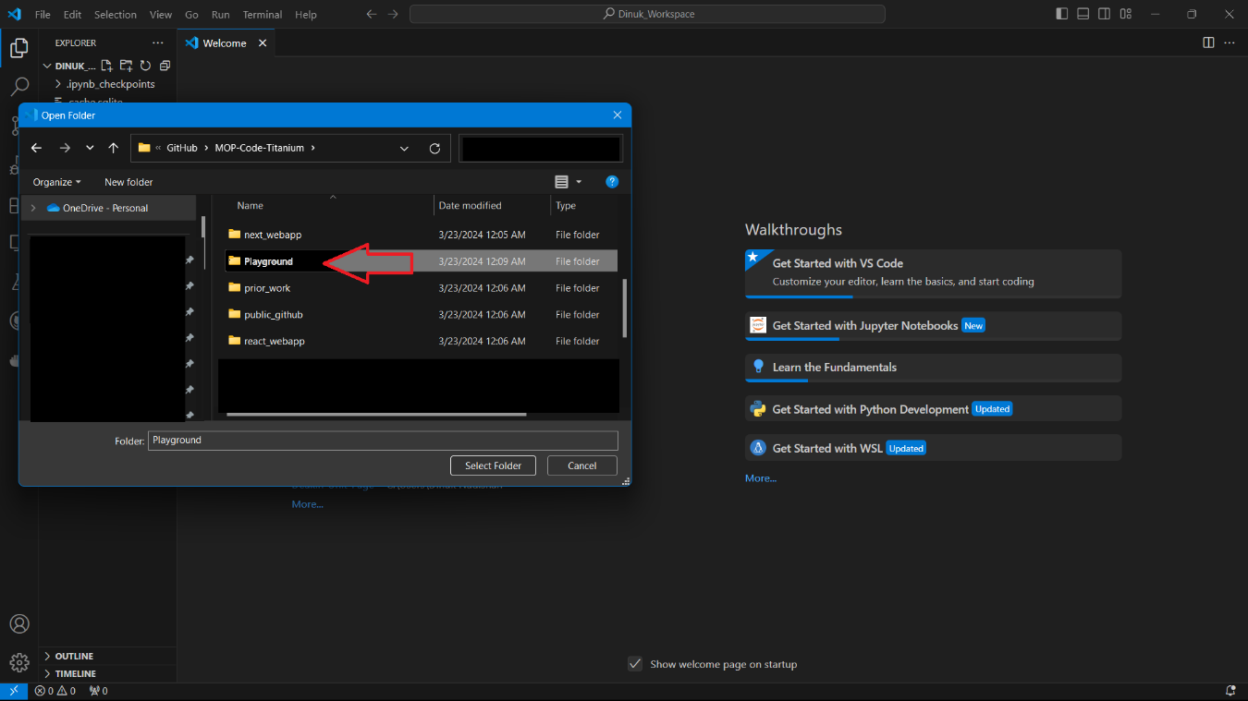

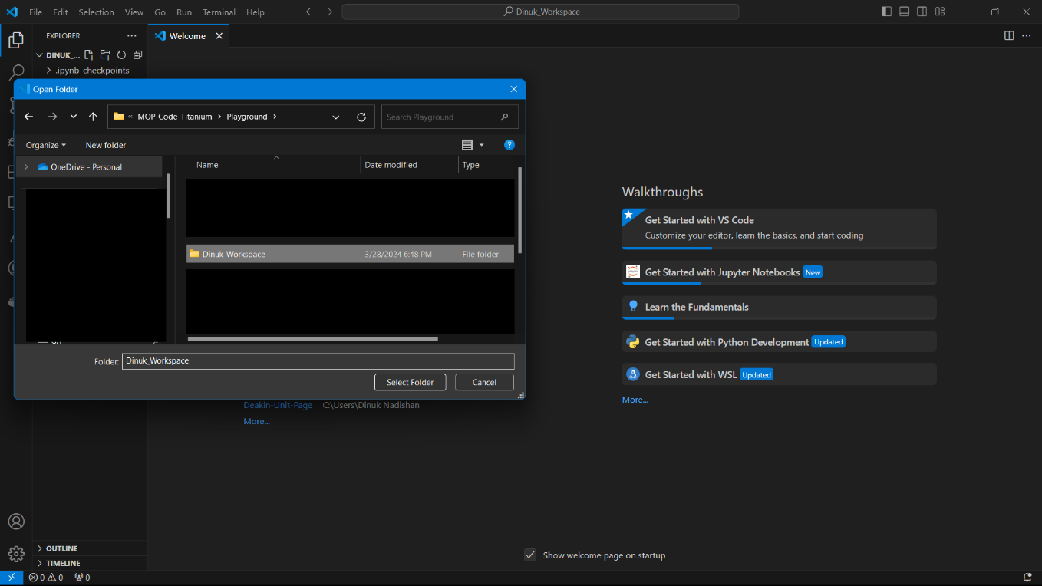

02. Open Visual Studio Code and make a .env file inside the folder where your notebook files are located.

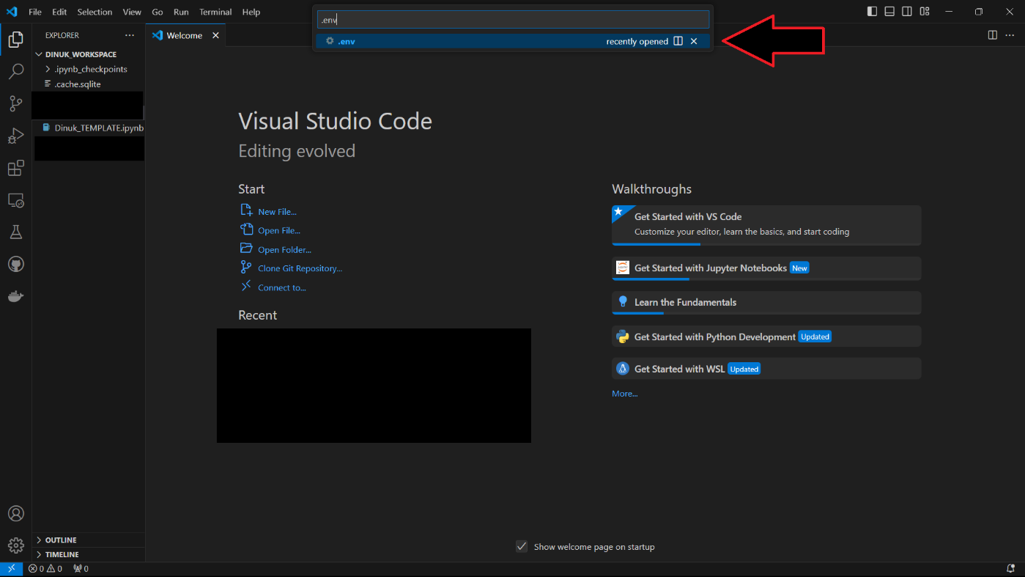

03. add your API KEY

API_KEY =HHlA###############NVv

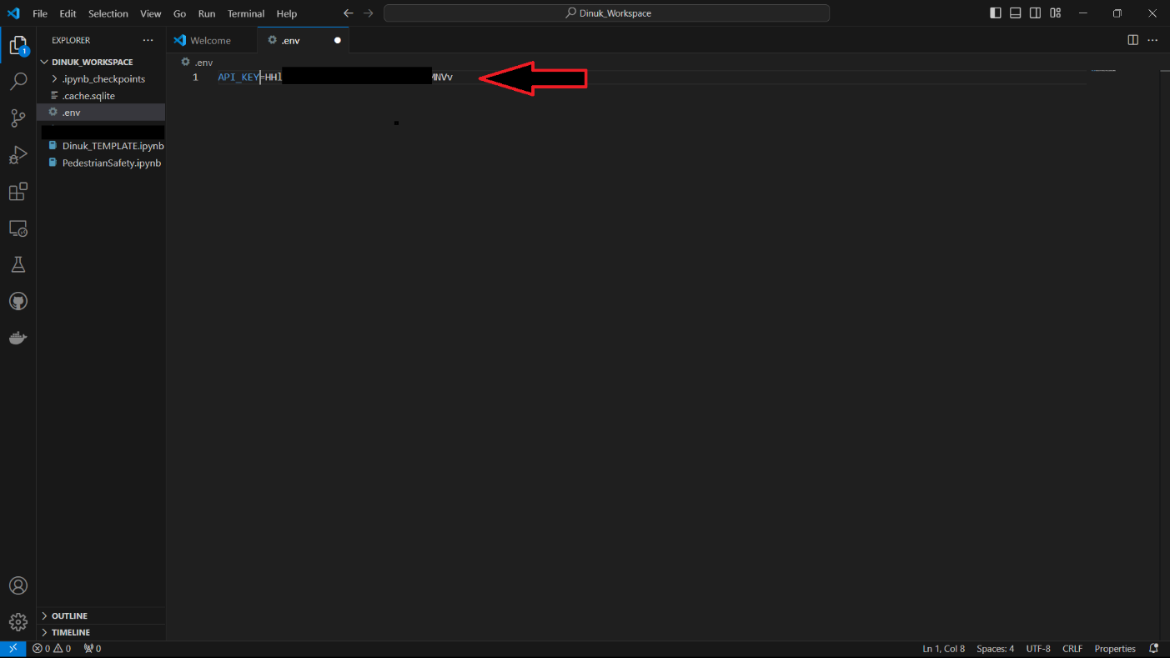

04. Save the File

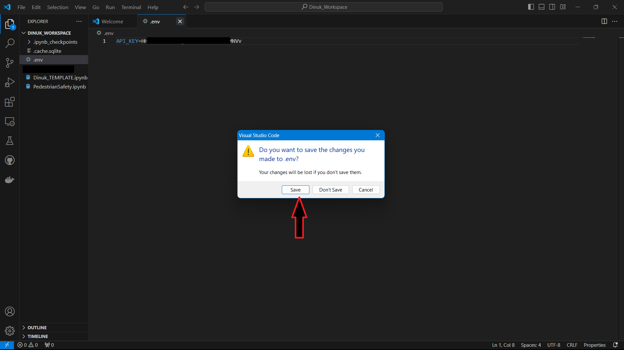

05. In your GIT desktop, you can see that the .env File is still there to commit.

We need to make it private.

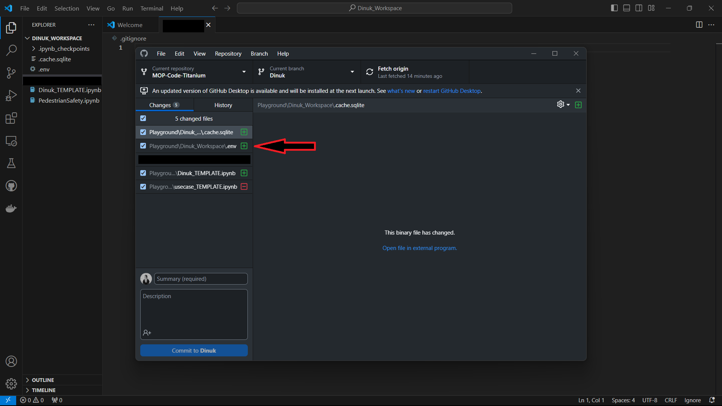

06. Go back to Visual Studio Code and Make a .gitignore file.

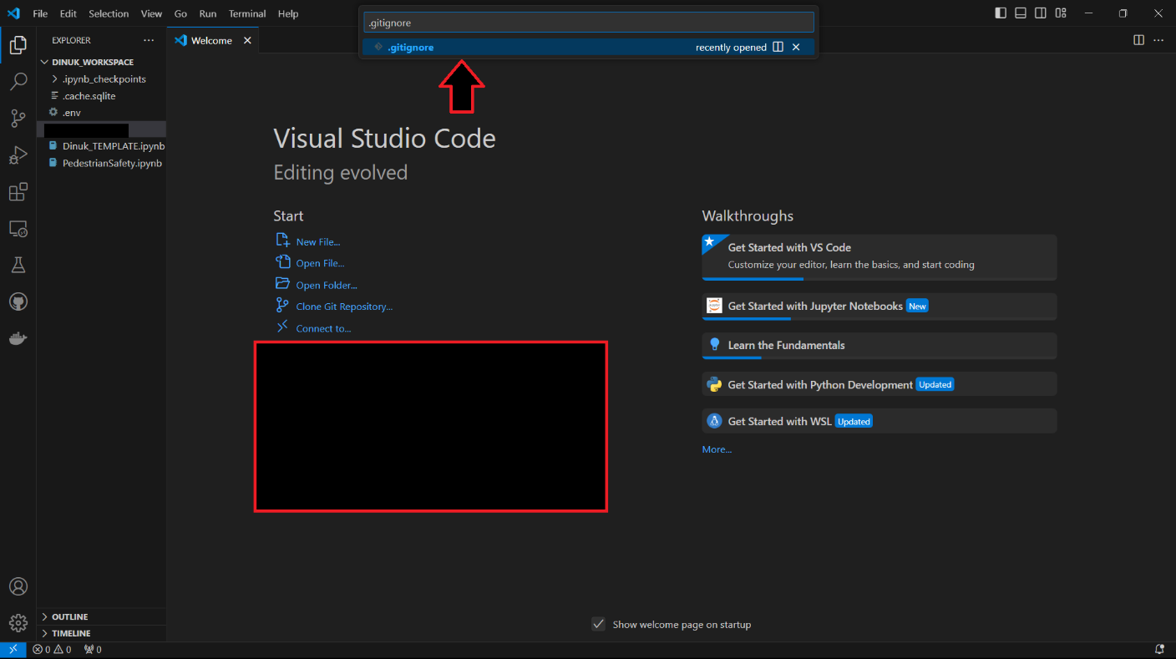

07. Inside the file, you can put file names to ignore.

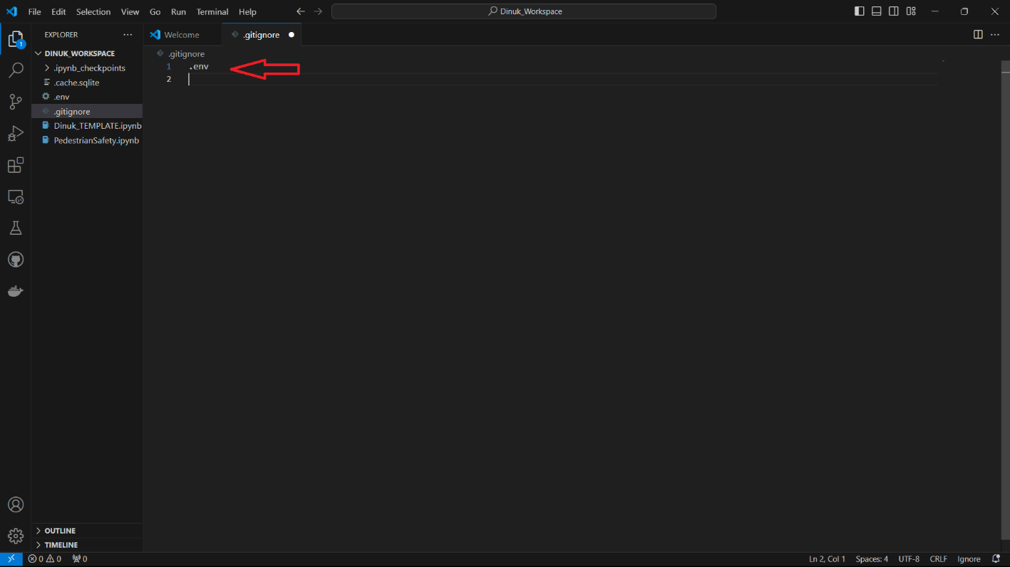

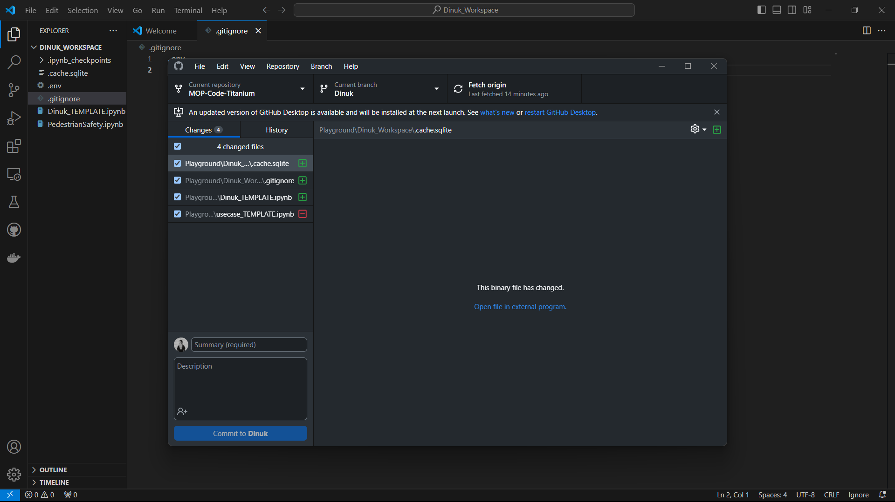

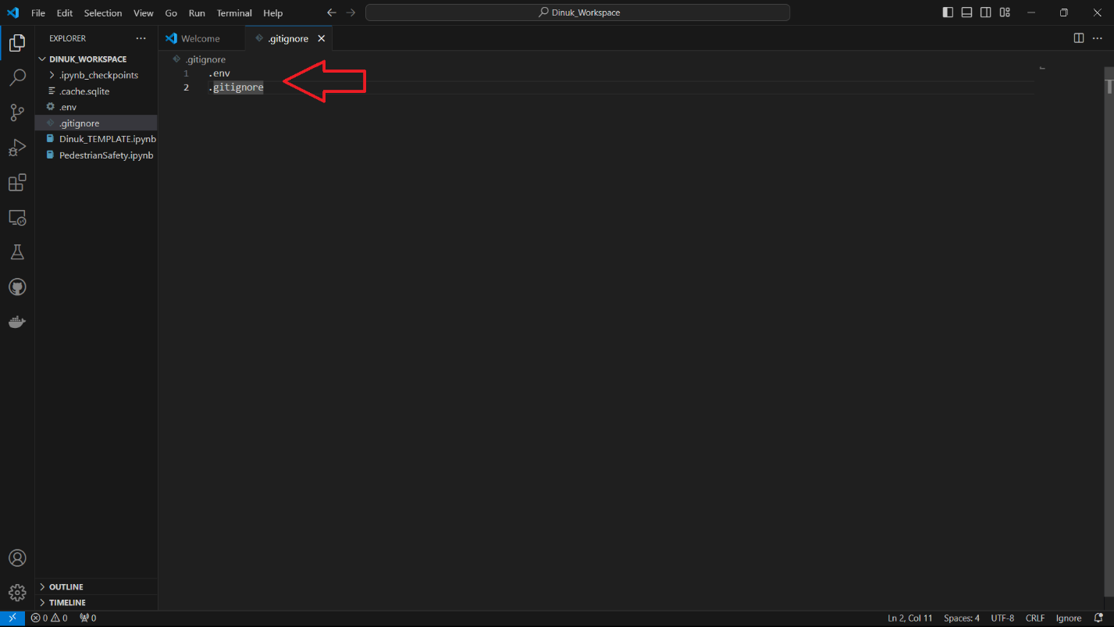

08. Now only the notebook files are there.

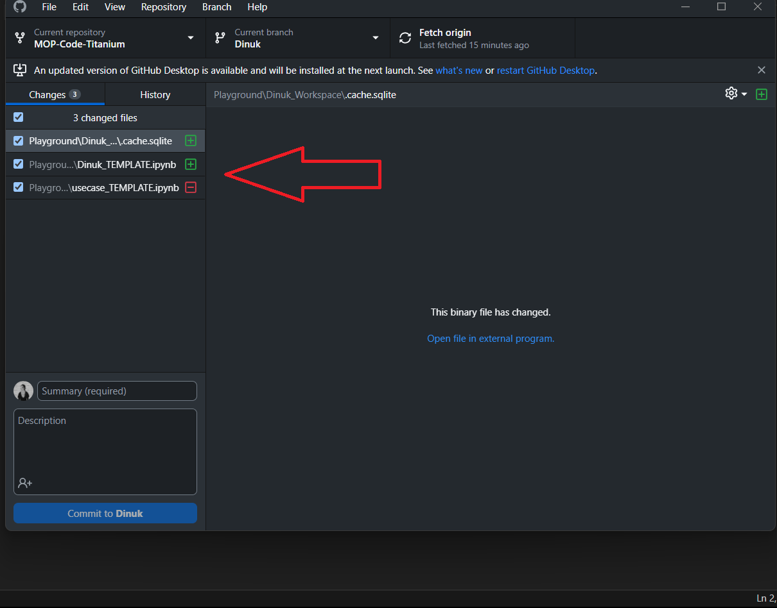

09. Call the API key inside your program.

import os

from dotenv import load_dotenv

load_dotenv()

api_key = os.environ.get("API_KEY ")

print("API Key:", api_key)

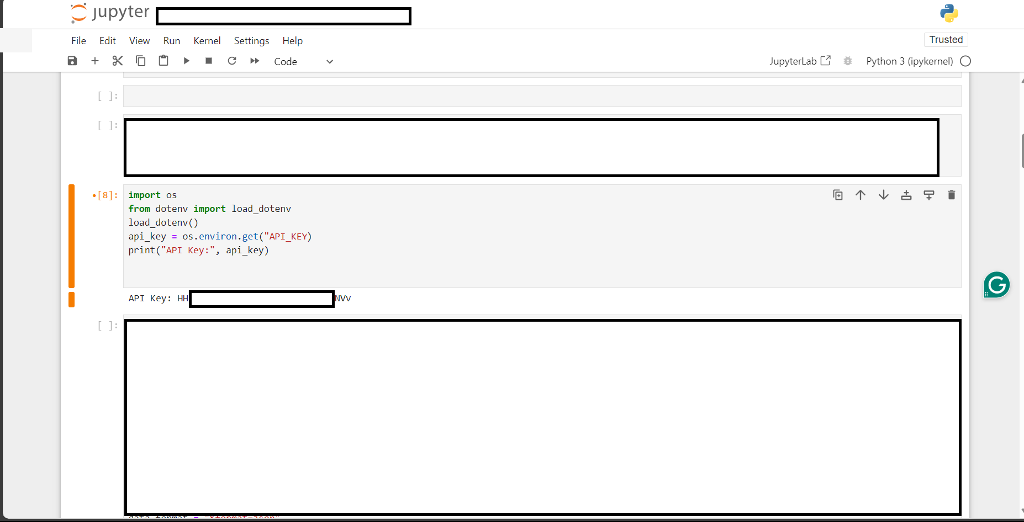

## Author

Dinuk 2024.v1